Android Units of Measurement

<http://stackoverflow.com/questions/2025282/difference-between-px-dp-dip-and-sp-in-android>

Use by Layouts (activity_main.xml)

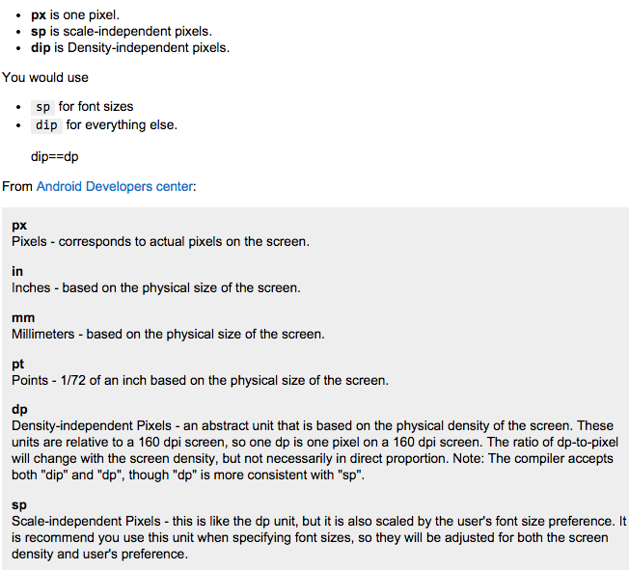

Creating Dimension Resource

<http://developer.android.com/guide/topics/resources/more-resources.html>

